Section 116 | EMPA Report No. | 168’349/704F

C O N F I D E N T I A L

Contract No. BRPR-CT96-0277 (DG 12 - RSMT)
BRITE EURAM BE96-3157
SIMCES
System Identification to Monitor Civil Engineering Structures

Task A1:
Bridge Tests
Progressive Damage Tests

Scenario: Pier Settlement 40 mm
No: 04

Measurement: 04

Type of Measurement: Forced Test, 40mm Settlement

Day: Thursday 13.08.1998 / Friday 14.08.1998

Night Managers: Camiel A. M. de Smet CdS (EMPA) and
Christoph Krämer CHK (EMPA)

Helping Hands: HH 1: Christoph Krämer CHK (EMPA),
HH 2: Manfred Waldvogel. MW (EMPA)
HH 3: Said Olia os (EMPA)
HH 4: Manfred Waldvogel. MW (EMPA).

Comments to Measurement:
None.

Acquisition Parameters
Number of Segments: 8
Number of Points/Segment: 8192
Sample Rate: 100 Hz

General Information
Filenames consist of the location, the signal was measured at plus the direction label. Direction Labels are set locally with
Girder locations:
L: Longitudinal, positive direction pointing to Koppigen
V: Vertical, positive direction pointing to zenith
T: Transversal, positive direction pointing to Bern
Example: 202T = location 202, transversal measurement

Koppigen Pier:
The sensors have been mounted in the plane of the pier, thus the measurement directions are skew relative to the girder.
L: Longitudinal, positive direction pointing to zenith
V: Vertical, positive direction pointing to Koppigen
T: Transversal, positive direction pointing to Zurich
Example: 531V = location 531, horizontal direction

Utzenstorf Pier:
The sensors have been mounted in the plane of the pier, thus the measurement directions are skew relative to the girder.
L: Longitudinal, positive direction pointing to zenith
V: Vertical, positive direction pointing to Utzenstorf
T: Transversal, positive direction pointing to Bern
Example: 421L = location 421, global vertical direction

Shaker Positions:
DP1 coincides with Reference 2 and DP2 coincides with Reference 1.

Files (AAA Format):
Line No | Description | Example
1 | Label, also giving no. Of averages | 139V.aaa|8Averages
2 | Number of samples contained | 65536
3 | Sample interval in seconds | 0.01
4... | Samples | -2.904082e-03

Configuration:
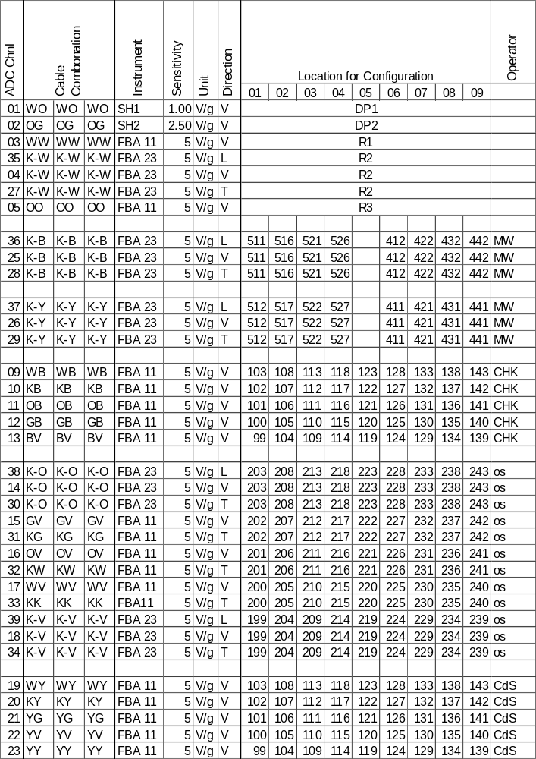

Sketches:
Girder, Top View
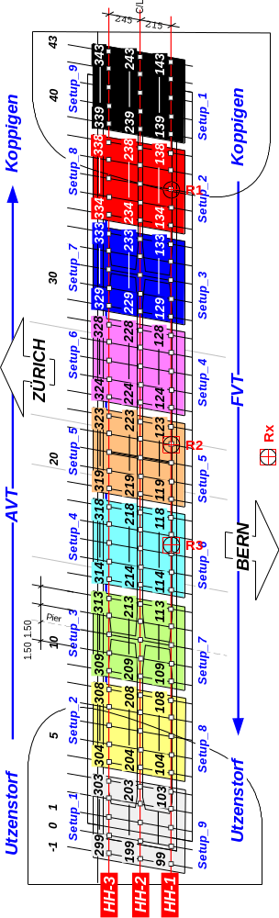
Koppigen Pier, Elevation
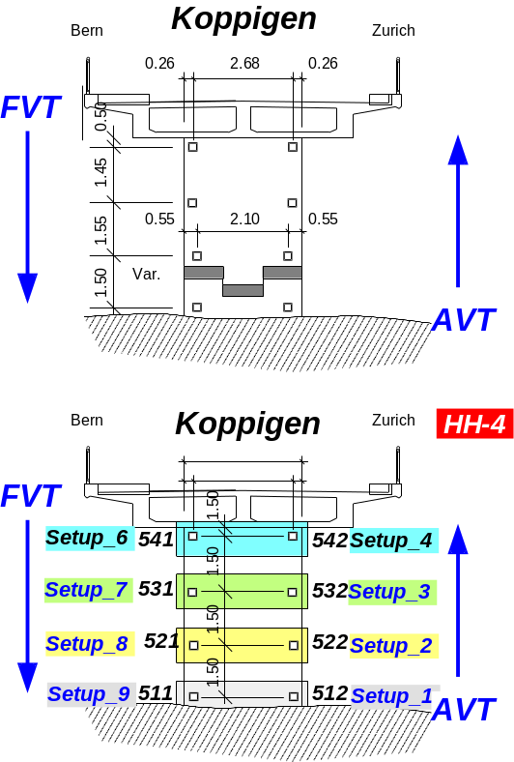

Utzenstorf Pier, Elevation
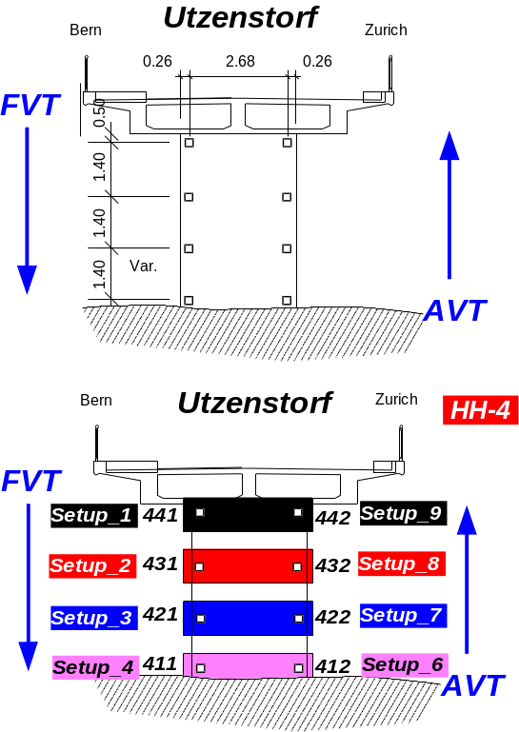

Acknowledgements
The EMPA and the SIMCES project appreciates the co-operation of the Road Department of the Canton Bern, Mr. Hegi and Mr. Jerin, the engineers of District IV, Mr. Horst and Mr. Wälchli. Also the contractor Fa. Sutter, Mr. Müller and co-workers had to proof their flexibility in various ways. Last but not least the research effort would not have been possible without the financial support of the Federal Office of Education and Science (BBW) which financed the work of the EMPA Section Concrete Structures.

